Network Revenue Protection Plan – 2023

Department of Transport and Planning
Metro Trains Melbourne
Yarra Trams
Bus Association Victoria
V/Line
Ventura
Kinetic

Table of Contents

1. INTRODUCTION AND PURPOSE 2
1.1. Overview 2
1.2. Revenue protection themes 4
1.3. Revenue protection priorities 4
1.4. Link between NRPP and operator revenue protection plans 4
1.5. Structure of the plan 4
2. BACKGROUND AND CONTEXT 5
2.1. Definition of fare evasion 5
2.2. Recent fare compliance levels 5
2.3. Revenue impact of fare evasion 6
2.4. A collaborative approach 7
2.5. A fair approach to fare compliance 7
2.6. Additional Authorised Officers 7
2.7. Overview of 2022 NRPP activities 8
3. FARE COMPLIANCE STRATEGY 9
3.1. Revenue protection themes 9
3.2. Responsibility for maximising fare compliance 10
4. 2023 REVENUE PROTECTION PRIORITIES 11
4.1. Leveraging new technology to support fare compliance outcomes 11
4.1.1. Context 11
4.1.2. Actions 12
5. Other Actions Aligned with The Four Themes Of Revenue Protection 12
5.1. Making the ticketing system easier to use 12
5.2. Compliance support 12
5.3. Ticket checking and Reports of Non-Compliance 12
5.4. Marketing and education 13
6. MEASUREMENT AND MONITORING 13
6.1. Revenue protection key performance indicators 13

INTRODUCTION AND PURPOSE

Overview
Under the relevant contractual arrangements, The Department of Transport and Planning (DTP) and public transport operators are required to produce an annual Network Revenue Protection Plan (NRPP) that describes how DTP, public transport operators, and Bus Association Victoria (BusVic) work together to protect revenue and implement Government policy across the public transport network.
Throughout much of 2020, 2021 and into 2022 the coronavirus (COVID-19) pandemic has caused a substantial amount of disruption to public transport use and the revenue protection activities laid out in previous NRPPs.
Despite these challenges, revenue protection activities have continued. In 2022 DTP has made further improvements to the PTV website and app that make it quicker and easier than ever to undertake ticketing activities such as check and add myki Money balance, register or set up Auto Top-Up. As more passengers have returned to the network with easing restrictions, they have been supported by Authorised Officers undertaking their duties in COVID safe ways and through delivery of targeted marketing campaigns promoting ticket readiness and contactless ways of topping up.
To track and measure fare compliance DTP normally conducts twice-yearly Fare Compliance Surveys each May and October. Due to the impacts of COVID-19 on public transport usage and social distance requirements, DTP was not able to conduct surveys in 2020 or October 2021.
The results from October 2022 found that a record high 96.9 per cent of passengers on the metropolitan network were fare compliant. This is 1 per cent higher than May 2022 and slightly higher than the previous highest result of 96.8 per cent measured in October 2019. In October 2022 fare compliance on regional trains was 95.0 per cent. Slightly lower than results measured prior to COVID-19, but higher than May 2021 and May 2022.
While the long-term impacts of COVID-19 on patronage and fare compliance are still unfolding, the May and October 2022 results are encouraging and show that even through a pandemic the vast majority of passengers in Victoria still choose to do the right thing.
In recognising that the majority of passengers intend to travel with a valid ticket, it is important that revenue protection activities continue to be undertaken in a way that reduces the chance of inadvertent fare evasion and enforcement targets deliberate fare evaders.
This plan continues the collaborative approach between DTP, operators and BusVic. It builds on previous work that focuses on maximising the number of passengers who travel with a valid ticket while also providing a high-quality passenger experience.

Revenue protection themes
The complexity of fare evasion behaviour means that a range of activities are required for effective revenue protection. As in previous years, the 2023 plan is based on four revenue protection themes:
- making the ticketing system easier to use: continuous improvement to the ticketing system to make it easier to use, access and understand, with the aim of improving the passenger experience
- compliance support: compliance promotion measures such as staff at stations and on trains, trams and buses and ticket barriers at railway stations
- ticket checking: Authorised Officers (AOs) checking tickets and reporting non-compliance to DTP
- marketing and education: customer information campaigns to help passengers be ready to travel and use high readiness products (such as auto top up or instant myki Money top up using the PTV app), as well as making it easier to use myki by continually improving education on how to use the ticketing system.
More detail on the four revenue protection themes can be found in section 3.1 below.

Revenue protection priorities
Supplementing the continuing four themes, the revenue protection priority area for 2023 is:
- Leveraging new technology to support fare compliance outcomes
This priority area, detailed in section 4, build on the 2021 and 2022 priorities of:
- Coronavirus recovery
- Supporting the transition to cashless ‘pre-pay’ buses

Link between NRPP and operator revenue protection plans
The 2023 NRPP focuses on network-wide priorities supported by activities on each mode. In addition, Metro Trains, Yarra Trams, V/Line and Kinetic prepare individual plans that include revenue protection priorities.
Revenue protection activities differ between operators and modes, but they all align with the overall objective of achieving a high level of fare compliance in a fair and equitable way.

Structure of the plan
The plan covers:
- background and context of Victoria’s revenue protection approach
- an overview of the fare compliance strategy
- revenue protection priorities for 2023
- revenue protection actions agreed by DTP and transport operators
- arrangements to implement and monitor revenue protection actions.
The plan will be implemented by the Revenue Protection Plan Implementation Committee (RPPIC), which includes representatives from DTP, operators and BusVic.
- BACKGROUND AND CONTEXT

Definition of fare evasion
The vast majority of public transport passengers in Victoria are fare compliant and travel with valid tickets. People travelling without a valid ticket are fare evading and this can be either inadvertent or deliberate. The Victorian Fares and Ticketing Conditions defines the conditions for valid tickets and can be accessed on the PTV website.

Recent fare compliance levels
Fare compliance is measured through surveys conducted twice a year in May and October. The estimated rate of fare compliance since 2011 is shown in figure 1 below.
Over this period, fare compliance on the metropolitan public transport network was lowest in May 2013 at 88.1 per cent. In October 2022, the metropolitan network result was highest at 96.9 per cent, slightly higher than the 96.8 per cent recorded in October 2019.
Due to the impacts of COVID-19 on public transport usage and social distancing requirements, the Fare Compliance surveys could not safely go ahead in 2020 or October 2021.
For October 2022, the metropolitan network fare compliance was 96.9 per cent, with metropolitan train the highest mode at 97.5 per cent and regional train recorded the lowest at 95 per cent.

Figure 1: Fare compliance by mode – October 2011 to October 2022
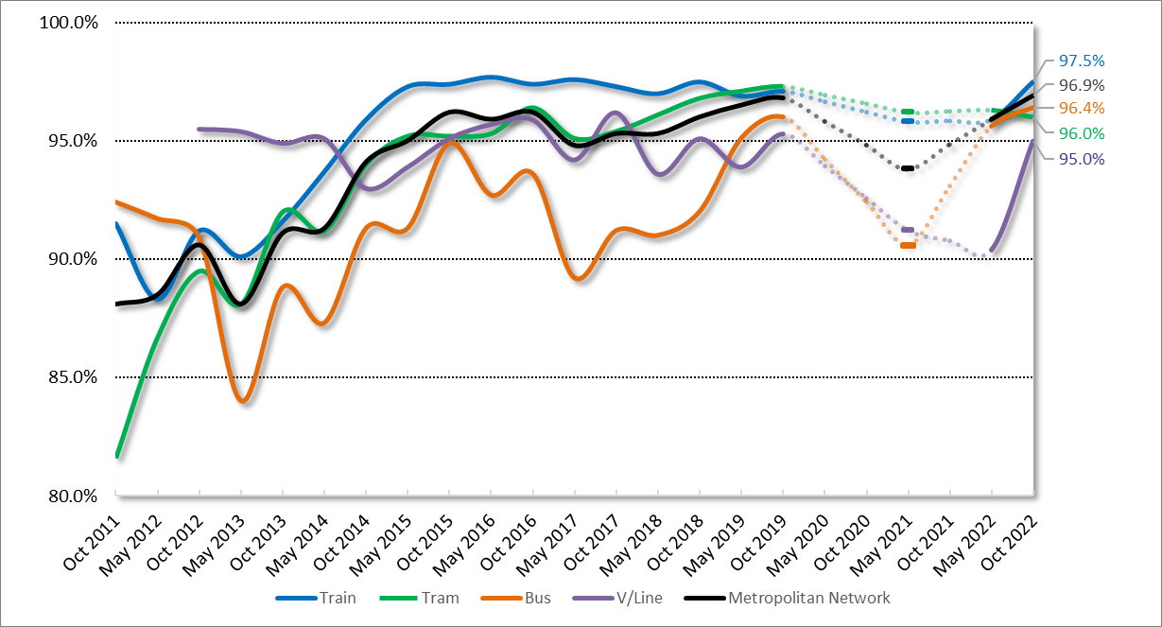
*NOTE: dotted lines indicate period in 2020 and 2021 with no fare compliance surveys.
It is not fully understood why fare compliance was lower in May 2021 and recovered on all modes in October 2022. Possible factors are;
- passengers adjusting to the permanent removal of cash from the myki bus networks in 2020.
- changes in the mix of passengers using the network in 2021 and 2022 due to COVID-19
A clearer indication of how the above factors may have impacted fare compliance is anticipated once more fare compliance surveys can be conducted in 2023 and ‘post COVID-19’ patronage has stabilised.

Revenue impact of fare evasion
The loss of farebox revenue for 2022 was estimated at $19.7 million ($15.5 million for the metropolitan network and $4.2 million for regional trains). Estimated revenue for this period was approximately $470 million (approximately $407 million for the metropolitan network and $63 million for regional trains).
For the pre COVID-19 equivalent 12 months in 2019, estimated loss of farebox revenue was $30.7 million (25.2 million for the metropolitan network and $5.4 million for regional trains). Though the estimated revenue loss in 2022 appears substantially smaller than in 2019, the estimated total revenue at that time was almost 50 per cent higher for the metropolitan network (approximately $812 million) and 35 per cent higher for regional trains (approximately $98 million).

A collaborative approach
DTP, public transport operators and BusVic have developed a collaborative approach to managing the shared challenges of fare compliance across the public transport network. This has promoted innovation and flexibility, which has contributed to strong fare compliance and a more consistent experience for passengers.
Metro Trains and Yarra Trams hold revenue risk via a sharing arrangement for total metropolitan farebox revenue. Accordingly, these operators have a financial incentive to attract more passengers and increase fare compliance on all modes across the network.

A fair approach to fare compliance
Following several reviews in 2015 and 2016, DTP and operators have made substantial improvements to the infringements process by focusing enforcement activity towards deliberate and recidivist fare evasion and more systematic discretion and use of official warnings in cases of inadvertent non-compliance.
Major changes included additional training for AOs, improved use of discretion for passengers with special and exceptional circumstances and improved use of official warnings in cases of inadvertent non-compliance.
To continuously improve, DTP and operators monitor customer satisfaction and feedback for opportunities to make further changes that improve fairness and customer outcomes further.
This plan also acknowledges that operators have continued working on improving passenger experience through initiatives including updated staff training, greater emphasis on customer service/education focussed activities and the recruitment of AOs from a broad range of backgrounds and experience.
Improving passenger experience is embedded in the current metropolitan train and tram contracts which is continuing to show positive results and will be further developed during 2022.

Additional Authorised Officers
The 2019/20 State Budget included funding for ten additional AOs to be recruited each year for 10 years, resulting in a total of 100 new AOs on the network. These additional AOs will provide an important increase in capacity to support revenue protection, safety and customer service across the network.
When determining the most appropriate distribution for each trance of additional AOs, consideration is given to a range of factors including;
- patronage
- Fare Compliance survey results
- existing staff on the network
- special events, planned and unplanned disruptions requiring AO support.

For financial year 2023/24 the 10 additional AOs will be employed as:
- 2 - Metro Trains Melbourne
- 3 - Yarra Trams
- 2 - V/Line
- 3 - MMAO (focusing primarily on metropolitan and regional bus).

Overview of 2022 NRPP activities
Similar to 2020 and 2021, the challenges presented by COVID-19 has meant implementing and measuring some of the 2022 NRPP actions has not been possible.
The below list outlines activities undertaken throughout 2022 to date aligned with the four revenue protection themes.
- Making the ticketing system easier to use:
- continued development of new PTV website and next gen PTV mobile app to further enhance myki ticketing integration.
- 20 Quick Top Up Enquiry Machines (QTEM) installed across the network and expansion of myki boundaries to three new train stations – Huntly, Raywood and Goornong.
- continued optimisation of the myki retail network with 14 new retail locations established.
- Compliance Support:
- maintenance of consistently closed and staffed myki ticket barriers
- bus operators have continued to monitor performance in ensuring ticketing devices are operational.
- Ticket checking:
- DTP and operators maintaining COVID-Safe ticket checking and enforcement practices, including support of mask compliance through much of 2022.
- maintaining high visibility of AOs across the network with ticket checking activities at close to pre-COVID levels.
- Marketing and education:
- Various campaigns targeting promotion of PTV app, cashless travel, registration and auto Top-Up delivered throughout 2022.
- face-to-face community education activities by operators (such as school presentations by AOs) reinstated in 2022 as and when safe to do so.
- continuation of non-enforcement customer education activities by AOs to positively influence fare compliance in a COVID Safe way.
- FARE COMPLIANCE STRATEGY

Revenue protection themes
The complexity of fare evasion behaviour means that a range of actions are required for effective revenue protection. Accordingly, the approach used by DTP and public transport operators is based on the four themes outlined in section 1.2.
Figure 2: Four themes of revenue protection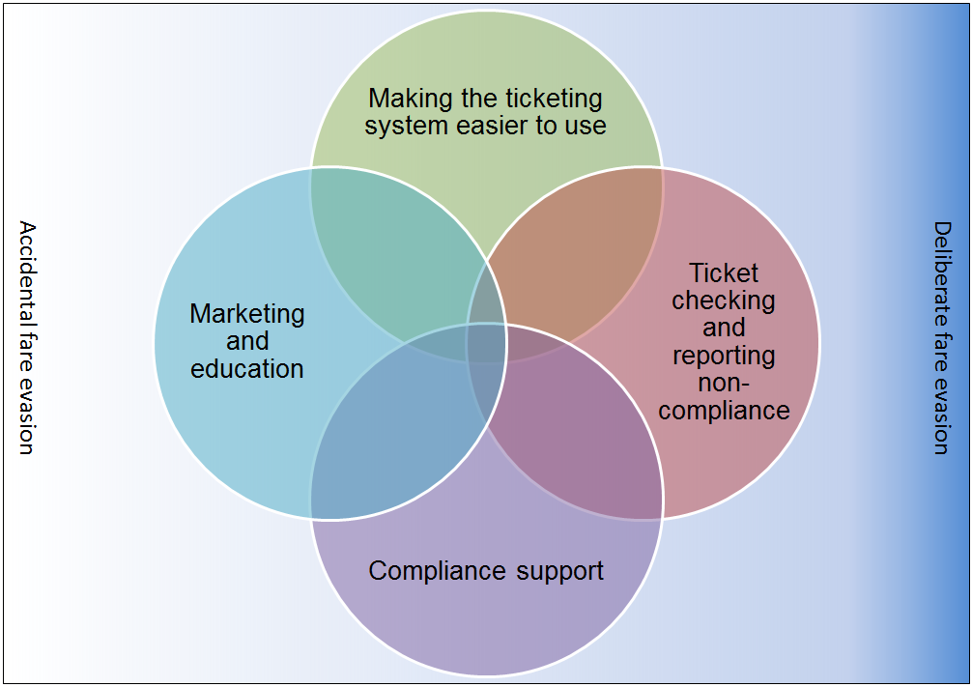
Each of the above themes in Figure 2 is important but none is sufficient on its own. Together, they support a suite of revenue protection measures that aim to make it easy for passengers to do the right thing and harder to deliberately and repeatedly fare evade.
Moreover, the culture of fare compliance extends to public transport staff each understanding the important role they play in supporting revenue protection. This includes frontline transport staff such as V/Line Conductors and railway station staff, tram Customer Service Employees and bus drivers.
The aim is to encourage passengers to see travelling with valid tickets as the norm while, at the same time providing better information to improve the passenger experience and reduce the likelihood of inadvertent fare evasion.
Using a revenue protection approach aligned to these four themes, fare compliance reached high levels across all modes prior to COVID-19 along with improved customer satisfaction and low complaints. The 2023 revenue protection actions will continued to be centered around this approach.

Responsibility for maximising fare compliance
Operators are required to meet a number of contractual obligations under their Agreements with DTP. While the conditions vary between operators, some key elements are:
- using reasonable endeavours to ensure passengers have valid tickets (including eligibility for concessions)
- employing and deploying agreed numbers of AOs
- working with DTP to develop, implement and comply with a Network Revenue Protection Plan
- maintaining accurate records and providing reports to DTP on revenue protection measures
- managing customer service staff to maximise fare compliance, (e.g. through closing/staffing ticket barriers at stations, providing information at tram and bus stops)
- supporting the conduct of the fare compliance survey through commitment of AOs and in the case of V/Line, train Conductors
- providing timely and accurate metrics to support monitoring of revenue protection activities.
DTP is responsible for:
- strategic public transport policy in relation to fares, ticketing, compliance and enforcement
- setting the strategic framework for revenue protection
- regulatory and legislative change relating to enforcement
- issuing and processing ticket infringement notices
- promoting innovation and overseeing specific initiatives to lead the industry
- managing updates to the ticketing conditions and new policy
- developing and undertaking marketing and information campaigns
- overseeing the operation and continued development of the myki system
- monitoring operator performance in line with contractual arrangements
- accrediting and regulating AOs to ensure they have the authorisation required to undertake their duties.
- undertaking regular fare compliance surveys, sharing the results with operators and publishing overall results in a timely fashion
- developing overall strategy and deployment plans for Multi-Modal Authorised Officers (MMAO) and ensuring implementation of the plan.
The Revenue Protection Plan Implementation Committee is responsible for delivery of the initiatives contained in this plan. Members of this group represent:
- Department of Transport and Planning
- Metro Trains Melbourne
- Yarra Trams
- Bus Association Victoria
- Ventura
- Kinetic
- V/Line.
This group will continue to meet every second month, with revenue protection meetings being held with individual modes in the intervening months.
- 2023 REVENUE PROTECTION PRIORITIES
As noted in Section 1, this priority area supplements the other long-term initiatives to improve fare compliance levels in 2023. These are discussed in more detail below.

Leveraging new technology to support fare compliance outcomes

Context
Rollout of the myki ticketing system commenced in 2007 and has undergone several improvements since then by embracing new and emerging technologies including faster readers across much of the network, Mobile myki for Android and Instant myki Money top up using the PTV app.
The current ticketing service contract is due to expire in 2023. Accordingly, in 2022 the Victorian Government opened an expression of interest process for the continued operation and upgrade of the myki ticketing system.
Upgrades that the Victorian Government will seek to have delivered to the myki system over the term of the next contract will include credit card tap on and tap off, additional smartphone payment options, and account-based options for passengers.
The priority for public transport ticketing is to ensure passengers can safety and seamlessly access, use and pay for public transport. The revenue protection priority through any future changes to the ticketing system (once known) is to ensure passengers are supported to travel with a valid ticket.
Separately, DTP has commenced projects to replace the ticket checking devices used by Authorised Officers and V/Line Conductors and replace the infringements database. These projects are expected to improve passenger outcomes among other benefits such as paperless reports of non-compliance.

Actions
- Once known, develop operational approach to support passengers through change/s to myki ticketing system - DTP, metropolitan train, tram, bus, V/Line.
- Once known, develop and deliver marketing and on-system messaging to promote changes to ticketing– DTP.
- Successfully deliver replacement ticket checking device and infringements database projects. – DTP, metropolitan train, tram, V/Line.
- Other Actions Aligned with The Four Themes Of Revenue Protection
In addition to the activities associated with the two priority areas, the following actions will be delivered by DTP, BusVic and public transport operators during 2022. Actions have been categorised according to the strategic elements identified in Section 3.

Making the ticketing system easier to use
- Oversee the operation and continued development of the myki system – DTP.
- Continue to make the myki system easier to use through progressive improvements – DTP.
- Optimise myki ticketing and retail networks to provide convenient top up options at key interchanges – DTP.

Compliance support
- Communicate regularly with staff to remind them of the importance of fare compliance – DTP, metropolitan train, tram, bus, V/Line.
- Continue to promote driver compliance with correct bus driver console usage and fault reporting – bus.
- Continue strategies to support revenue protection activities by V/Line Conductors and other staff – DTP, V/Line.
- Continue to staff and close wide ticket barriers at gated stations in line with contractual arrangements – metropolitan trains, V/Line.

Ticket checking and Reports of Non-Compliance
- Deploy AOs strategically, using survey and other data, to a combination of high value areas and general network coverage to normalise fare compliance – DTP, metropolitan train, tram, bus, V/Line.
- Continue to increase the visibility of AOs across the public transport network - DTP, metropolitan train, tram, bus, V/Line.
- Improve AO coverage in regional Victoria – DTP, V/Line
- Continue to improve consistency of AO’s use of discretion for cases of special and exceptional circumstances – DTP, metropolitan train, tram, bus, V/Line.
- Continue to improve support for vulnerable passengers’ accessing public transport – DTP.

Marketing and education
- Develop and deliver marketing and functional messaging to encourage passengers to travel with a valid ticket at all times and build better understand of the ticketing system – DTP.
- Give presentations at schools and universities to educate students on behavioural requirements and the need to have a valid ticket – metropolitan train, tram, bus, V/Line.
- Improve promotion of high readiness ticketing products by AOs, V/Line train Conductors and frontline staff – DTP, metropolitan train, tram, bus, V/Line.
- MEASUREMENT AND MONITORING

Revenue protection key performance indicators
DTP and operators work together to establish a consistent set of metrics that can be monitored to assess the effectiveness of revenue protection activities. These indicators are aligned with the TCE reforms and reflect the breadth of revenue protection activities, including:
- Fare Compliance Survey results
- Touch on rate survey
- Customer satisfaction with AOs
- Customer satisfaction with the myki ticketing system
- Proportion of passengers using ‘high readiness’ ticketing products
Revenue protection metrics are regularly reviewed to ensure they remain relevant and changes are made where improvements are identified, or different metrics are required.
Operators also use a range of metrics for planning and monitoring their own revenue protection activities. They work with DTP to coordinate activities and monitor revenue protection trends across the network
As in previous years, DTP and operators will share relevant data and prepare specific reports to inform the development and implementation of revenue protection activities.

